Test report
We are suppose to find out the correct order of how integers are inserted in to the hash table. When there are multiple choices, When there are multiple choices, the smallest number is always taken.
To test whether there are bugs existing in the source code, I designed 8 cases ranging from one normal cases to some special cases that might lead to malfunction. To be more specific the 8 cases and the conditions they contain are listed in Table.1
Furthermore I want to find out whether the order of the given input affect the running time of the program

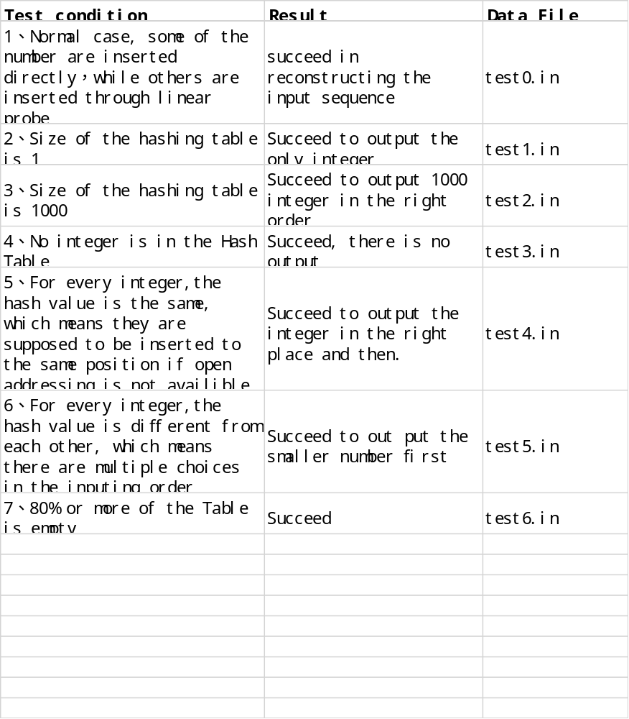

The program runs perfectly, and the test cases contains all the situation that we took thought of: the big data situation, the empty table, the situation that all but one integer doesn’t need linear probe, the situation that no integer need linear probe.

Time complexity: In the program the process from line 68 to line 95 consumes the most time, other part is obviously insignificant compared with the many for loop inside a while loop, so we just have to calculate the time complexity of this part. In the worst case situation, all but one integer doesn’t need linear probe. So every integer has to go over all the integers that inserted before it to find its position in the output array, so the time complexity is as follows:
T(N)=0+1+2+3+4+…..+N-1=N(N-1)/2
According to the formula, the Time complexity of the program is O(N^2)

Space complexity: The program uses two arrays, the size of each array is O(N), so the space complexity of the program is O(N)

Optimization:
The main problem of optimization is to change the insertion sort from line 68 to line 97, however, the sorting isn’t a classical sorting that sort all the integers from the smallest to the largest. Although some integers are bigger, but it is inserted earlier, so insertion sort by some alternation is the only choice. If there is any optimization, then it would be a completely different algorithm.

